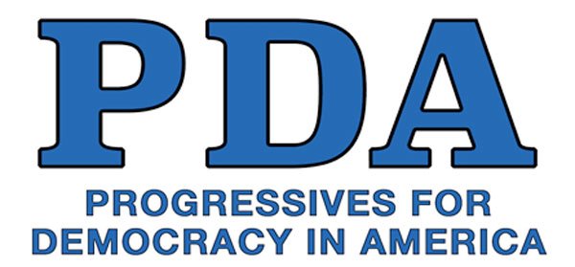
To the Honorable Representative (First and Last Name):

As your contituent, I am/we are writing to urge you to be an original co-sponsor of this year’s expanded and improved Medicare for All legislation, which will soon be introduced in the House by Rep. Pramila Jayapal.

The USA desperately needs Medicare for All. Our current system costs roughly twice as much per capita as any other industrialized country in the world, yet still leaves tens of millions uninsured and several millions more underinsured. These failures cause 10,000s of preventable deaths every year, as well as economic hardships including medical bankruptcies.

Medicare for All would provide all necessary health care for all people residing in the United States, free at the point of service with no financial barriers, while empowering all patients to choose their health care professionals. It would save businesses, taxpayers, and patients, as well as the federal, state, and local governments $billions each year, lowering per capita costs while delivering high quality healthcare for all.

We have studied the numerous serious failings of the US health care system, and concluded that there is no moral, economic, or public health rationale for maintaining and subsidizing for-profit insurance companies. They impose burdensome demands on health professionals, forcing them to waste time and money complying with red tape. Medicare for All would free doctors, nurses, pharmacists, and others to provide care by eliminating these unnecessary complications.

The COVID-19 pandemic further exposed the deadly flaws in our broken mainly privatized system. Its unacceptably poor health outcomes include unnecessary costs and delays, as well as rampant waste, fraud, abuse, and—worst of all—denial of life-saving care. These negative effects disproportionately harm the most vulnerable among us including women, rural and urban communities, People of Color, as well as poor and working families.

Tragically, we’ve been regressing on health care. With Republicans intent on gutting public health programs and people currently losing Medicaid protections, we need you to show your strong support for Medicare for All now more than ever. Profiteering is causing hospital closures and loss of medical care providers in entire regions, creating “health care deserts.” These trends imperil tens of millions of people.

I will/We will follow up with a phone call to your office in the next few days to see if you would like more information about the Medicare for All legislation and to ask if you will be signing on as an original co-sponsor.

Sincerely,

