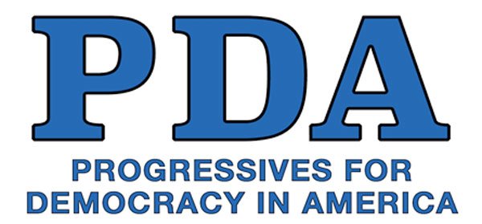

(Date of Delivery)

Dear Representative (Representative’s Last Name):

As your constituent(s), I am/we are writing to urge you to protect seniors in our district by cosponsoring Rep. Mark Pocan’s H.R. 732, The Save Medicare Act. I/we also urge you to stand up against one of the most serious threats facing American seniors and all American households: Medicare privatization schemes including “Medicare Advantage” and so-called “Accountable Care Organizations” (e.g., ACO REACH). These undermine Medicare and take healthcare for seniors in the wrong direction.

Rep. Jan Schakowsky drafted an informative letter, signed by 90 of your House colleagues, that explains how privatization of Medicare results in worse coverage and higher costs for Seniors. This, while providing no benefits to seniors, taxpayers, or anyone else - except for greedy special interests.

The Medicare program is one of the crowning achievements of the US Congress. Its popularity is virtually universal amongst the American people because it has saved countless lives and dramatically improved the quality of life for seniors. However, in recent decades, there has been a dangerous and accelerating trend towards the privatization of Medicare.

This trend has led to skyrocketing out-of-pocket costs, delays, and denial of life-saving health care, as well as medical bankruptcy among seniors—reversing much of the progress achieved through Medicare. This has caused increasing dissatisfaction with healthcare among US seniors.

Nothing positive has been achieved through the privatization of Medicare. Contrary to self-serving claims made by for-profit insurance companies, Medicare privatization has never saved money, improved service, nor eliminated waste, even though it has led to widespread denial of coverage. In short, seniors in our district are paying more for health care but getting much less for their money.

Please help lead the way in eliminating the rampant waste, fraud, and abuse inherent to private for-profit insurance company involvement in health care. Please do all you can to return the Medicare program to its original conception as a universal single-payer system for seniors, free from unnecessary complications, delays, denials, and profiteering.

I will follow up this letter by reaching out to your office to set up a meeting. I look forward to discussing this urgent matter with you.

Sincerely,

Your constituent,
(Your name, contact info, chapter)

